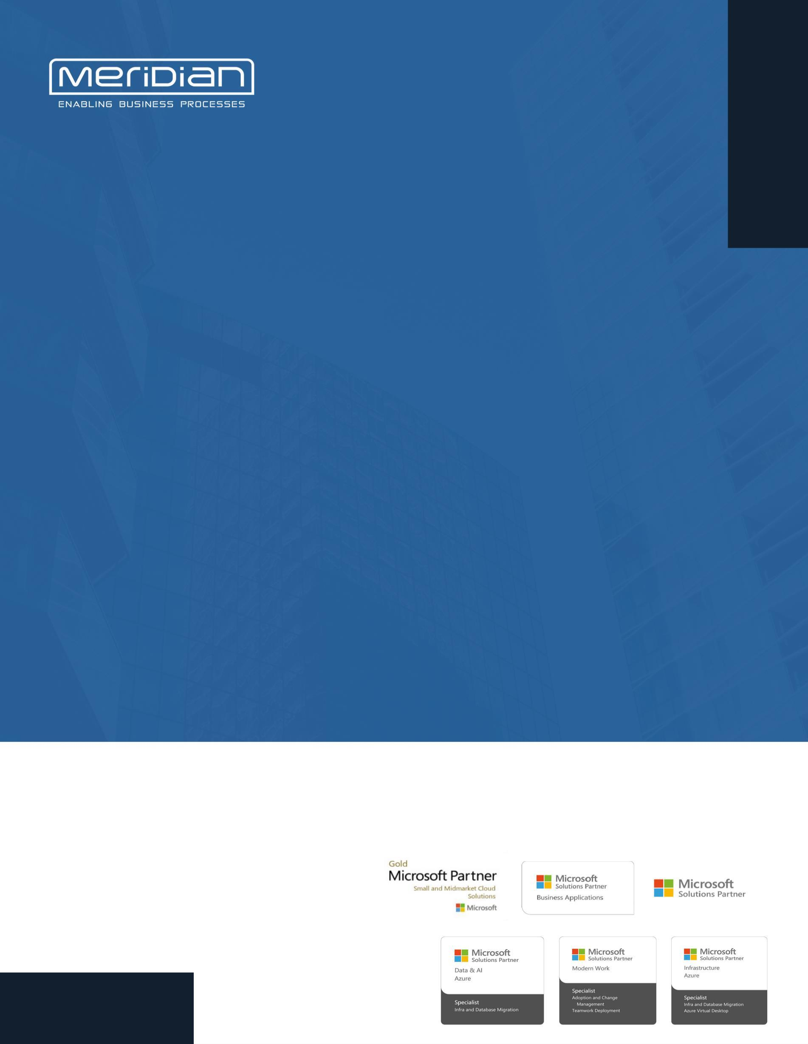

OFFICE 365 SERVICE STATUS REPORT May-2025

Incwert Value Research

Overview of Activities

1.1 User and License Management

License Type | Total License Allotted | Assigned License | Available License
Microsoft 365 Business Basic | 2 | 1 | 1
Microsoft 365 Business Premium | 35 | 24 | 11
Microsoft 365 Business Standard | 4 | 2 | 2
Microsoft 365 E5 Information Protection and Governance | 20 | 19 | 1

Tenant User Summary:
- Total Users in the Tenant: 52
- Blocked/Unlicensed Users:14
- Active/Licensed Users:29
Action Required: Review the unlicensed users and remove any unnecessary accounts from the tenant.
https://admin.microsoft.com/?login_hint=migration%40incwert.com&source=applauncher#/users

Shared mailbox:
A shared mailbox can be used by a group of people, like a support team, to receive and send email from the same email address. Select a shared mailbox to add or remove members, set up automatic replies, manage aliases, and more. Learn more about shared mailboxes
Total shared mailboxes created in the tenant: 04

1.2 Teams and Groups:

Type | Total | Created in May
M 365 GROUP | 10 | 0
DISTRIBUTION | 2 | 0
MAIL-ENABLED | 00 | 00
SECURITY | 13 | 00

To learn more about the different types of groups and where to create teams, watch the video in the link. https://www.microsoft.com/videoplayer/embed/RW10GYp

Service Health and Incident Resolution:

Microsoft ticket raised: 2 tickets raised to Microsoft

Security Updates:

2.1 Secure score:

‎Microsoft Secure Score‎ measures total opportunity for protection of your identities, data, devices, apps, and infrastructure, and your points achieved toward that protection.

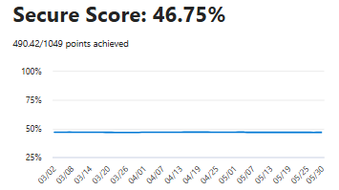

The Secure Score of 45.48% indicates that there is room for improvement in the organization's security posture. Here are some key recommendations for improving this score:

Key Recommendations:

Block Office applications from creating executable content: To block Microsoft Office applications (Word, Excel, PowerPoint, etc.) from creating executable content, you can follow several approaches based on your environment (e.g., group policy, registry, or Office settings). Executable content includes macros, ActiveX controls, and embedded files that can be potentially harmful.

Block Win32 API Calls from Office Macros: Prevent Office macros from making calls to Win32 API, reducing the risk of malware execution.

Block Executable Files from Running Unless They Meet Prevalence, Age, or Trusted List Criteria: Ensure only trusted and verified executable files are allowed to run based on predefined criteria.

Block Office Communication Applications from Creating Child Processes: Prevent Office communication apps from spawning additional processes that may pose security risks.

Enable Microsoft Defender Antivirus Email Scanning: Enable Microsoft Defender Antivirus to scan all incoming and outgoing email attachments for threats.

Please go through the below link for more recommendations Microsoft Secure Score - Microsoft Defender

2.2 Compliance Score:

Compliance Manager measures your progress in completing actions that help reduce risks around data protection and regulatory standards. Find guidance and documentation

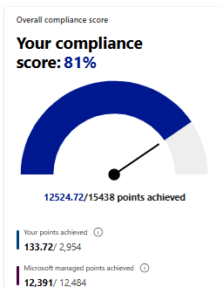

Improvement actions provide guidance on task completion which can improve your org's compliance score. Action points can take up to 24 hours to update. Learn more about improvement actions

2.3 Adoption Score:

Your organization's ‎Adoption Score‎ is the total of its people’s experiences and technology experiences scores, which are each comprised of several categories of data. Scores are not provided at the individual user level.
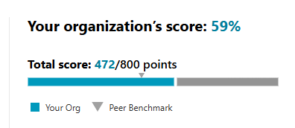
To improve the Adoption score please follow the link for recommendations
https://admin.microsoft.com/?login_hint=migration%40incwert.com&source=applauncher#/adoptionscore

2.4 Usage Reports:

2.4.1 Email Usage:

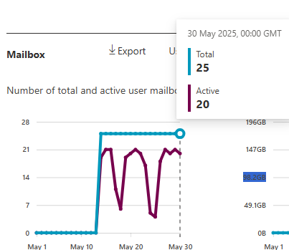

Please go through the given link for complete details on the usage of emails

https://admin.microsoft.com/?login_hint=migration%40incwert.com&source=applauncher#/reportsUsage/EmailActivity

2.4.2 Teams Usage:
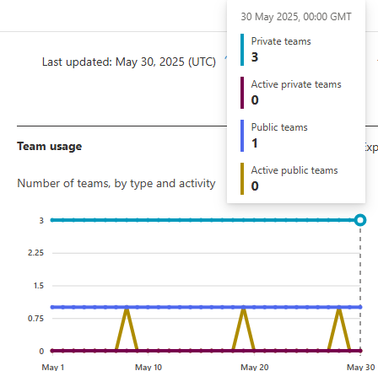

Please go through the given link for complete details on the usage of Teams

https://admin.microsoft.com/?login_hint=migration%40incwert.com&source=applauncher#/reportsUsage/OneDriveSiteUsage

2.4.3 OneDrive Usage:

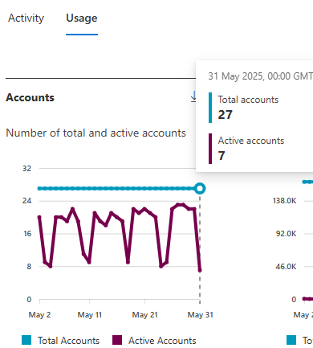 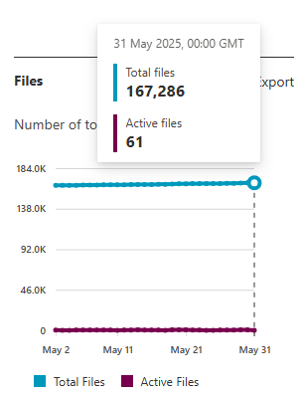 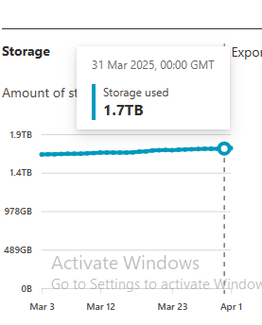 Note: 1.7 TB total used of 1.9 TB.

Please go through the given link for complete details on the usage of OneDrive

https://admin.microsoft.com/?login_hint=migration%40incwert.com&source=applauncher#/reportsUsage/OneDriveSiteUsage

2.4.4 SharePoint Usage:

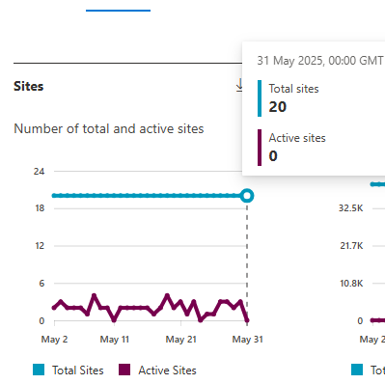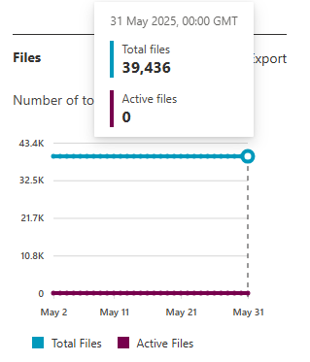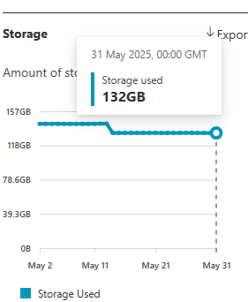
Note: 125 GB total used out of 135 GB
Please go through the given link for complete details on the usage of Share point
https://admin.microsoft.com/?login_hint=migration%40incwert.com&source=applauncher#/reportsUsage/SharePointSiteUsageV1

Security Policies:

3.1 Devices:

Devices managed by Platform:

Windows: 30

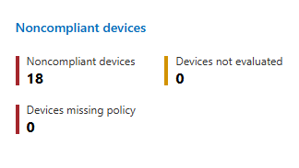

MacOS: 0

IOS: 5

Android: 18

3.2 Policies:

1. Configuration policies:
Policy name | Platform | Policy Type | Remarks
Android Device restriction | Android Enterprise | Configuration settings | Successful
BitLocker Key | Windows 10 and later | Configuration settings | Successful
Configure Windows LAPS Policy | Windows 10 and later | Configuration settings | Successful
Default EDR policy for all devices | Windows 10 and later | Configuration settings | Successful
Intune App protection Policy | Windows 10 and later | Configuration settings | Successful
Device Restriction | Windows 10 and later | Configuration settings | Successful
Intune data collection policy | Windows 10 and later | Configuration settings | Successful
DLP policy | Windows 10 and later | Compliance portal | Testing
IOS Device Restriction | iOS/iPadOS | Configuration settings | Successful
Silently move data automatically to OneDrive

2. Compliance policy
Policy name | Platform or OS | Status | How many Users | Remarks
Compliance Policy | Windows 10 and later | Implemented | 19 | Successful
IOS Compliance Policy | iOS/iPadOS | Not Implemented | 0
Android Compliance | Android Enterprise | Not Implemented | 0

3. Conditional policy

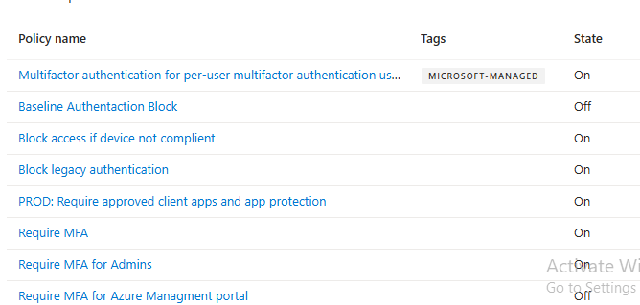

Reports:

1. Sign in logs shared

2. Audit logs of the tenant have been shared.

THANK YOU
For further information, please contact. Email: tech.support@onmeridian.com Web: http://onmeridian.com
Meridian Solutions Private Limited,
Office no-1103 -1105, Tower B4, Spaze I-Tech Park, Sohna Road, Sector 49, Gurugram, Haryana, 122018 Toll Free: 1-800-102-2150

